5th March 2019

**YOKOHAMA to begin European sales of “GEOLANDAR X-MT” mud-terrain tyre for SUVs and pickup trucks with high hobby usage**

YOKOHAMA announced today that it will begin European sales of the “GEOLANDAR X-MT”, a mud-terrain tyre in its GEOLANDAR brand of SUV and pickup truck tyres, from this spring. The tyre will be available in six sizes – 35×12.50R20 LT 121Q to 7.00R16C 108/106N. The “GEOLANDAR X-MT” was introduced previously in the North American market and has enjoyed a favourable response in a market where SUVs and pickup trucks are highly popular.  
  
The “GEOLANDAR X-MT” was developed as a more hobby-oriented version of the “GEOLANDAR M/T G003” that was introduced in Europe in spring 2018. The “GEOLANDAR X-MT” delivers an even better performance on off-road terrain, including rocky trails. The tyre design is based on the “rock concept”, which replicates an image of rocks in nature. This concept has generated the “rock concept tread”, a large side block and the GEOLANDAR brand logo and enhances the vehicle’s off-road image. The “GEOLANDAR X-MT” off-road performance exceeds that of the “GEOLANDAR M/T G003”. The “GEOLANDAR X-MT”’s wide lug groove pattern delivers superior traction on various terrains, and its large side block contributes to better drivability on rough roads. In addition to enhancing the vehicle’s off-road performance, the “GEOLANDAR X-MT” minimizes off-road noise. Its response to drivers’ needs for greater off-road performance is making the “GEOLANDAR X-MT” a core tyre in YOKOHAMA’s GEOLANDAR brand of high-value-added tyres preferred by discerning users.  
  
GEOLANDAR is YOKOHAMA’s global brand for SUVs and pickup trucks. YOKOHAMA is accelerating its introduction of new additions to the brand to meet diversifying needs in the SUV market in recent years. In addition to the “GEOLANDAR X-MT” and “GEOLANDAR M/T G003” mud-terrain tyres and the recently introduced new highway terrain “GEOLANDAR X-CV”, the GEOLANDAR brand also includes the “GEOLANDAR A/T G015”, an all-terrain tyre; the “GEOLANDAR H/T G056”, a highway tyre for midsize and large SUVs; and the “GEOLANDAR SUV”, for urban crossovers and small/midsize SUVs.  
  
YOKOHAMA has established its hobby tyre strategy as one of core elements of the broader consumer tire strategy included in the Company’s three-year medium-term management plan, Grand Design 2020 (GD2020), implemented from 2018. In line with its hobby tyre strategy, the Company is accelerating the development of new products and expanding the size line-up of existing products suitable for use with various types of hobby vehicles, from race cars to classic cars.

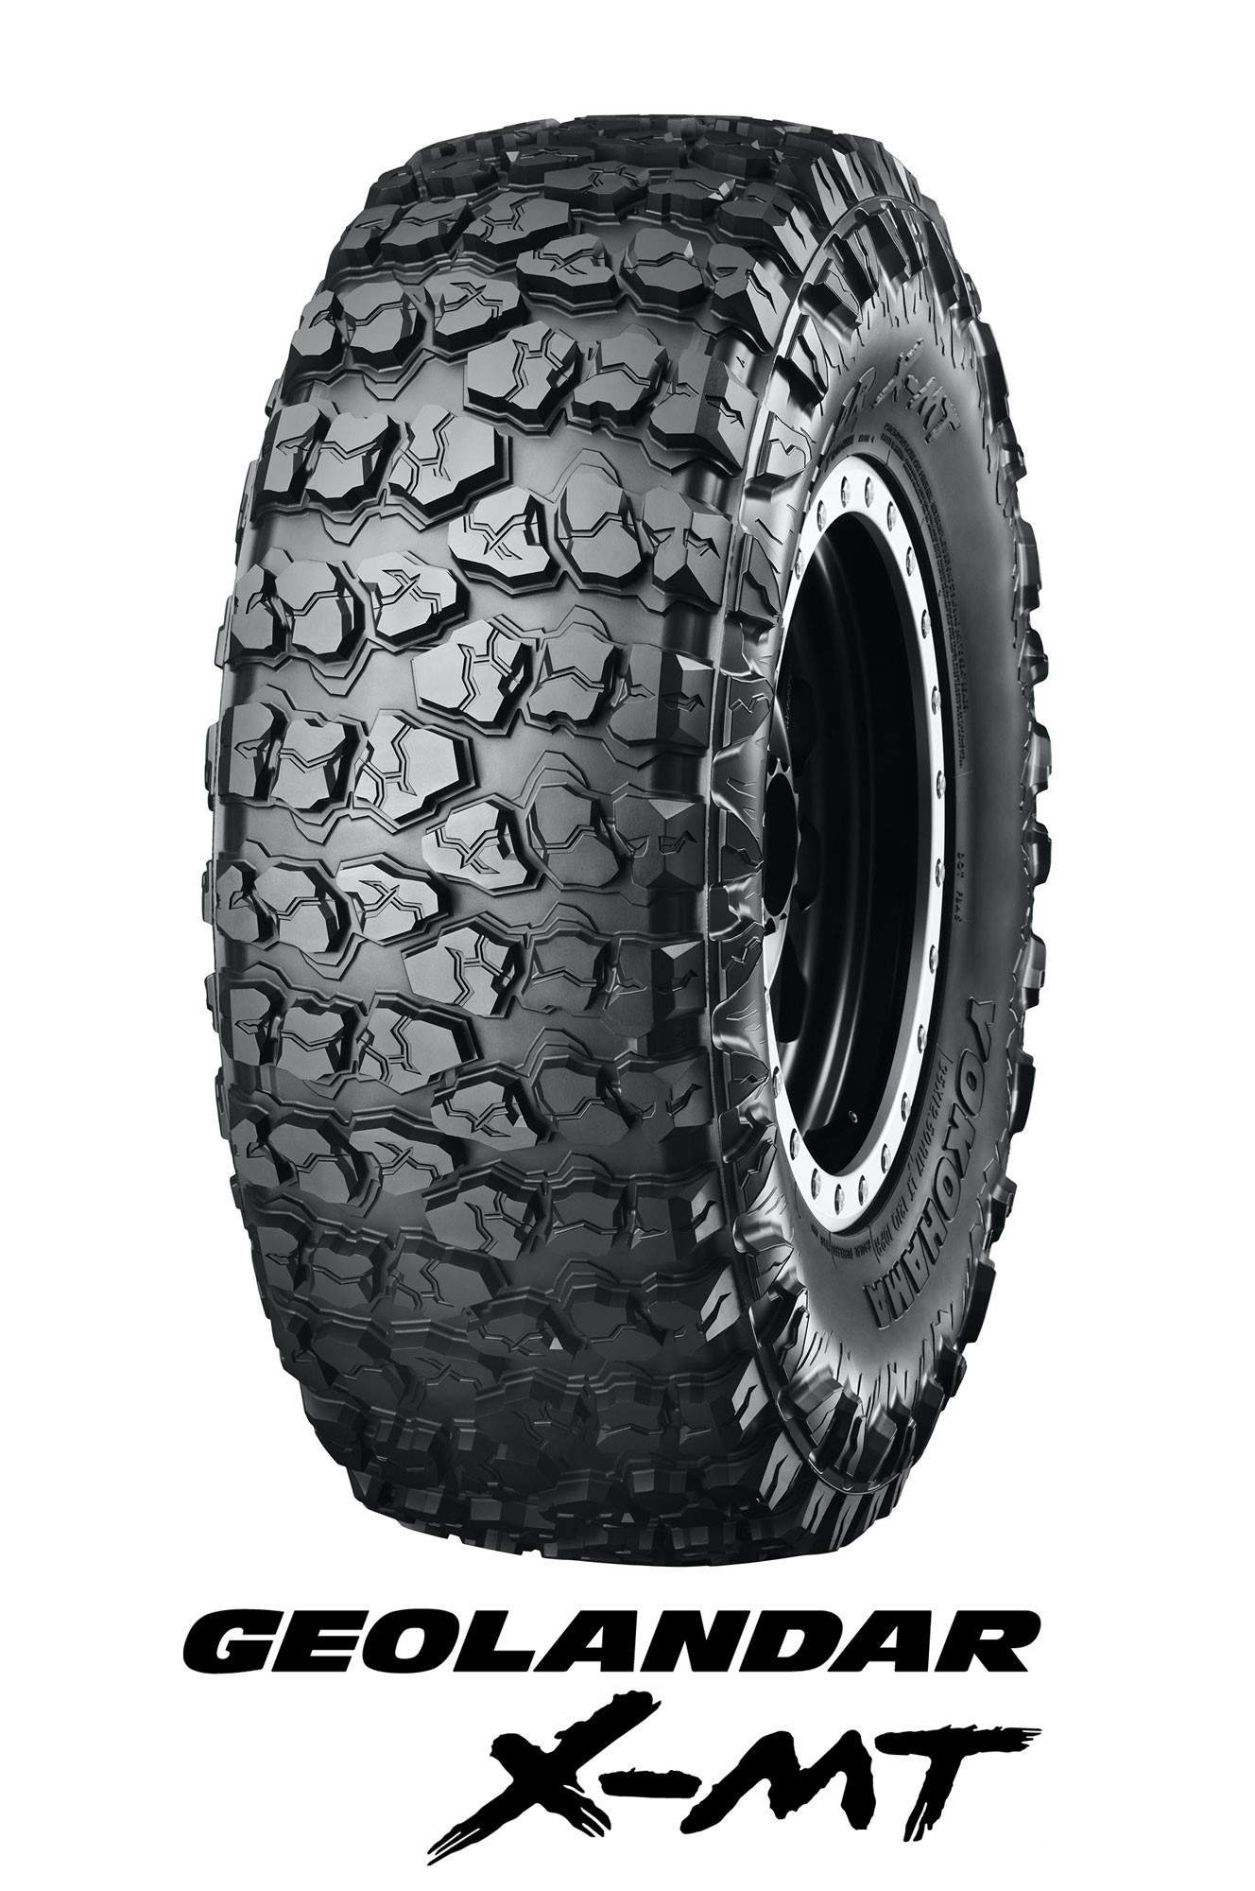

*GEOLANDAR X-MT*

##### *Product Features*

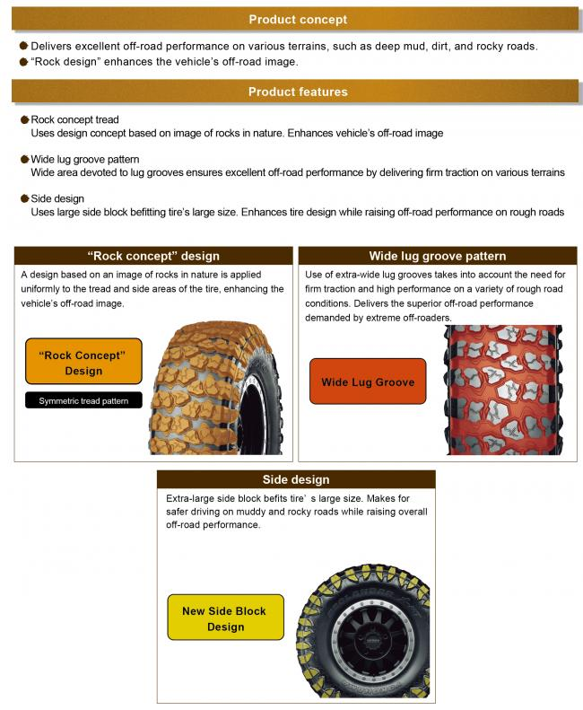

##### *Available sizes*

